Lab5 Notes

No issues at all. I exported the SQL script for reference.

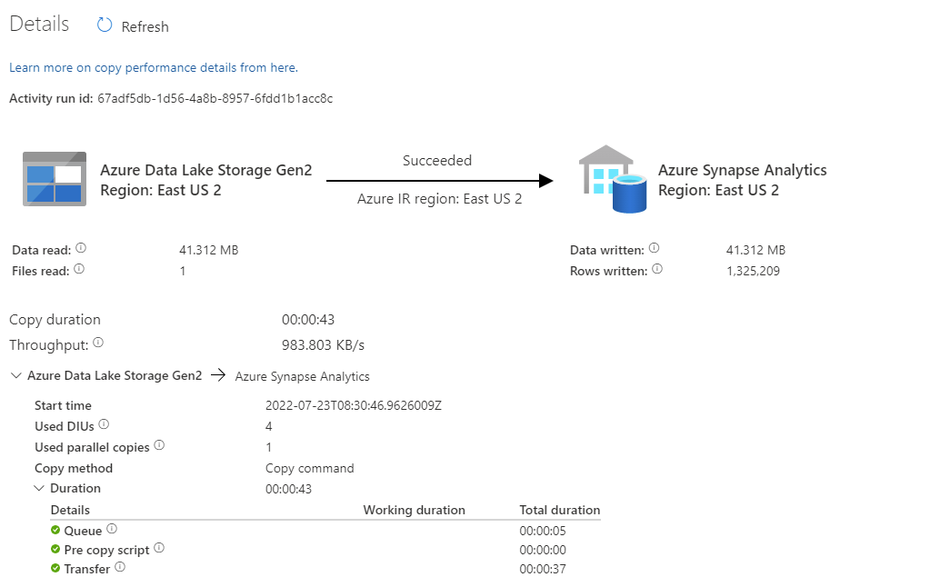

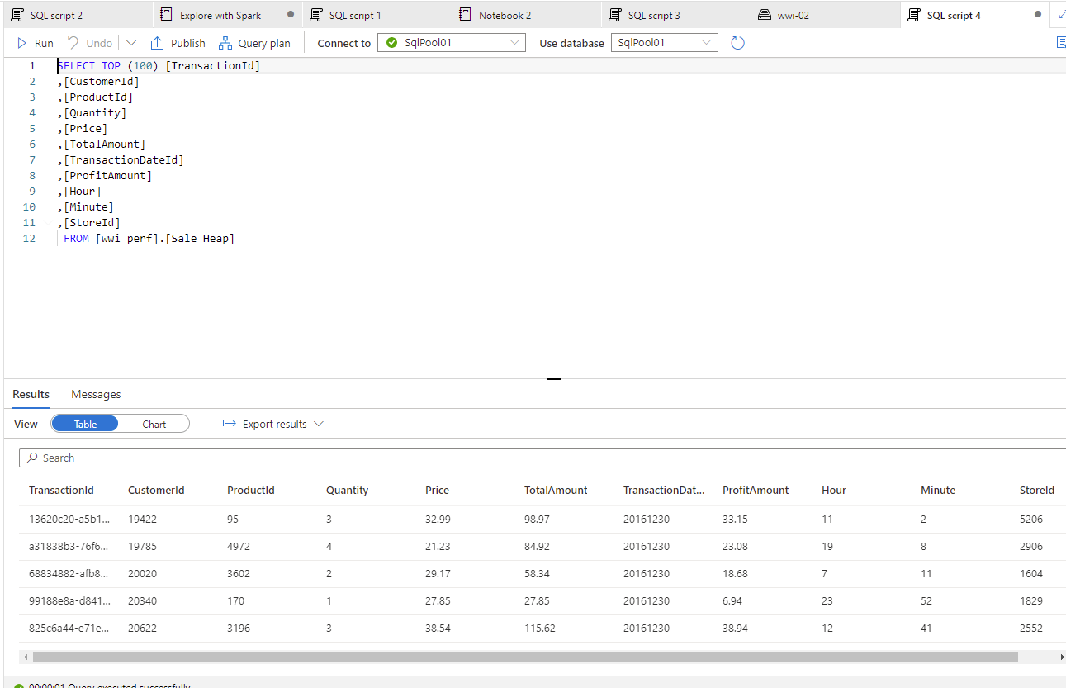

Exerc 2 Task 3 is a preparation for a later lab.

.\dp-203-setup-Part03.ps1 took more than 38min to finish loading 100K documents to CosmosDB. The Synapse pipeline is created, runs and then it is deleted.

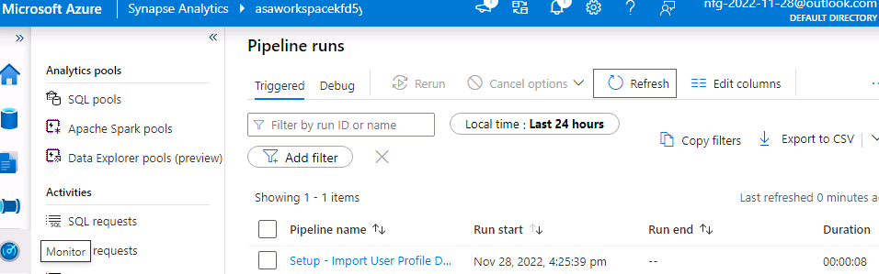 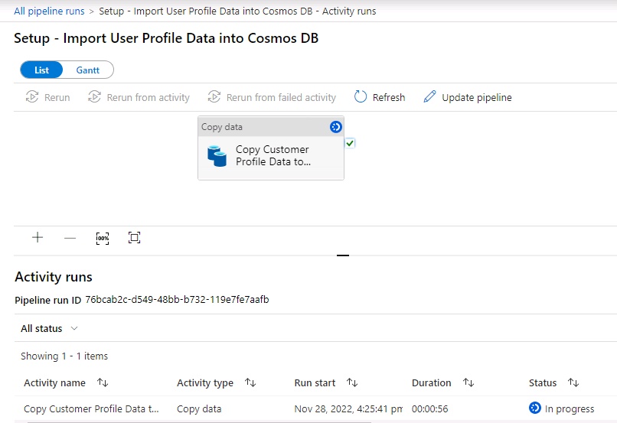

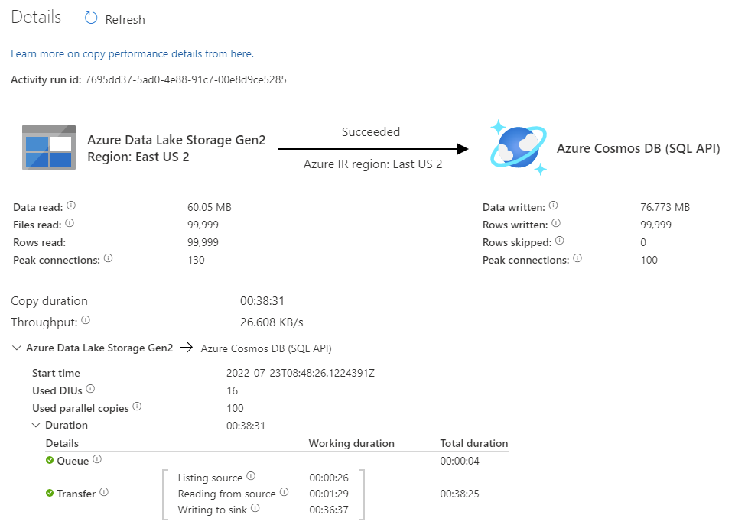 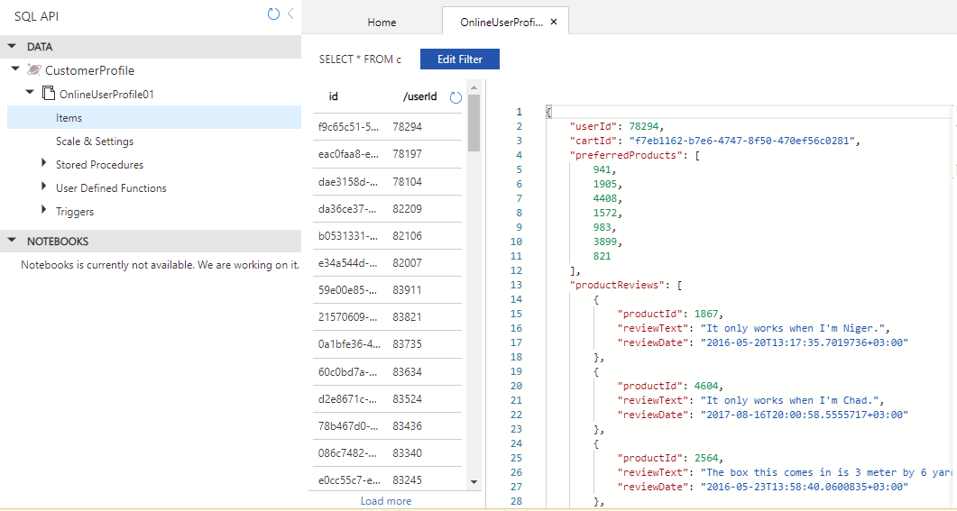

This was the last setup script. So, the remaining labs should have all that is needed.

In one of my runs I got several errors that were because an expired authentication token.

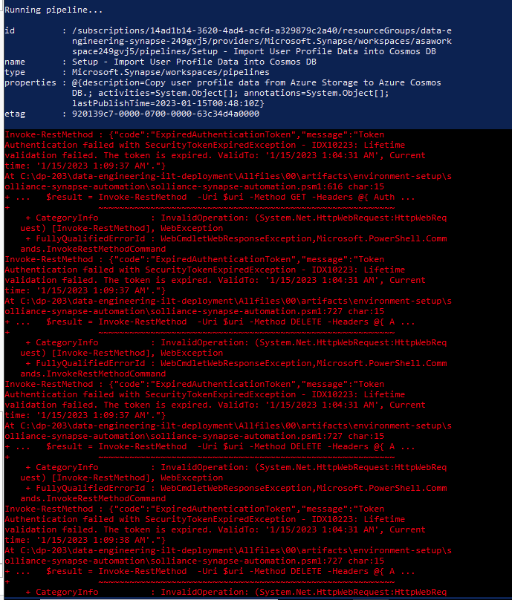

This seems to not cause later problems. At least I can see that the json files were uploaded to Cosmos.

